AI ASSISTED CODING

LAB 8.4

NAME:A.DINESH

ENROLL.NO:2403A52080

BATCH:04

**TASK-01:**

Write a test case to check if a function returns the square of a number.  
Then write the function with help from GitHub Copilot or Cursor AI.

**PROMPT:**

Generate a python code to find the square of a given number like 2**2=4 ,3**2=9 and also give the test cases to check the efficiency of the code.

**CODE:**

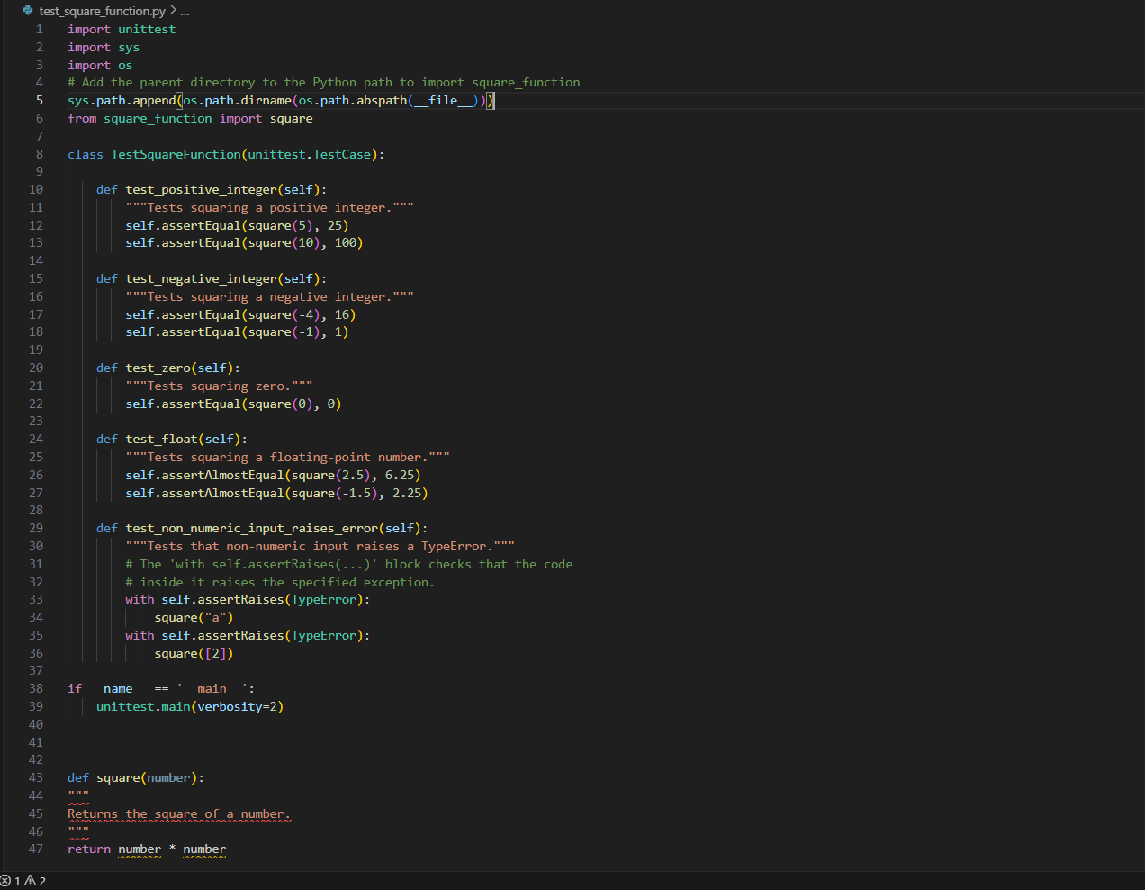

**OUTPUT:**

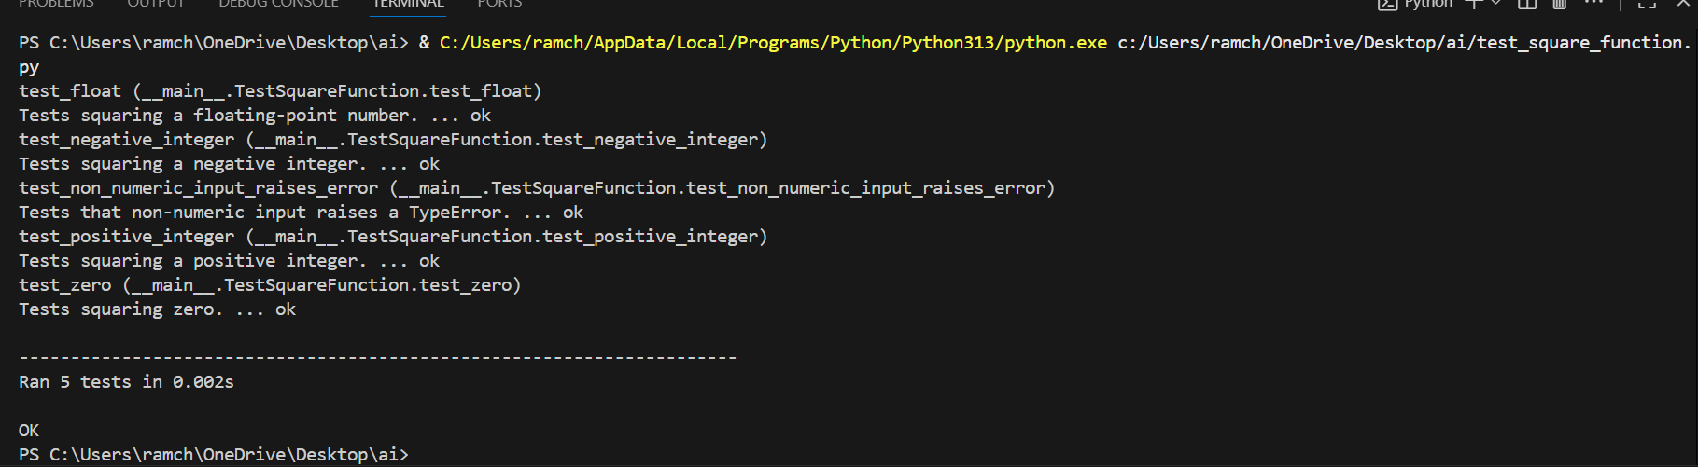

**OBSERVATION:**

The code generated by the ai is efficient to calculate the square of the given number. And it also gave the test cases to find the efficiency of the code it also embedded the code with the particular print messages according to the datatype.

**TASK-02:**

Create test cases to validate an email address (e.g., contains @ and .com).Use AI assistance to implement the validate_email() function

**PROMPT:**

Generate the python code of test cases to test whether the email entered is correct or not. Use appropriate conditions mail like @ should present in it and .com should present in it.

**CODE:**

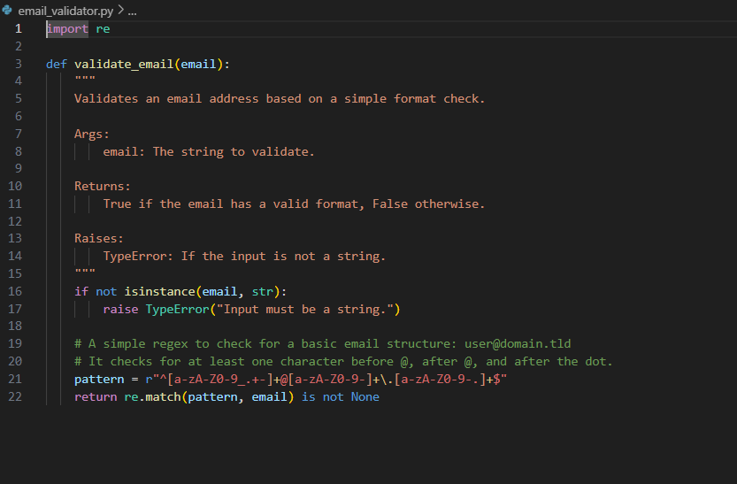

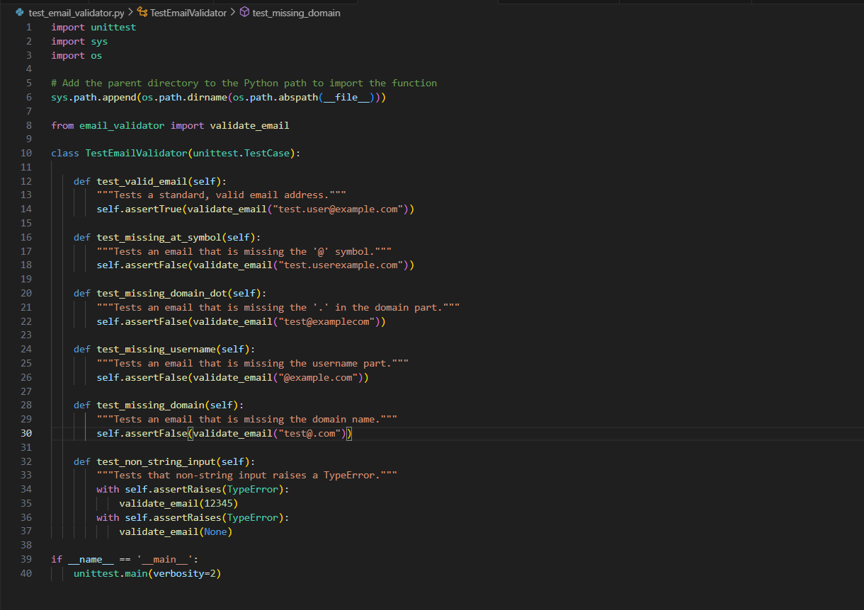

**OUTPUT:**

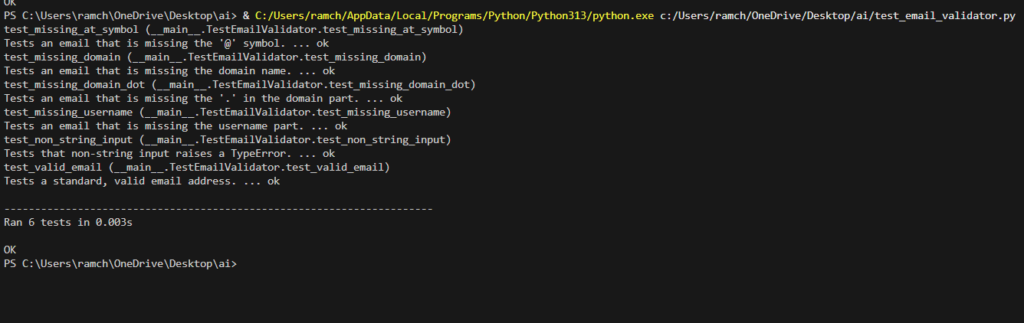

**OBSERVATION:**

The code generated by the ai provided many test cases to check whether the entered email is correct or not . It has used many conditions like @ should be present in the email entered.

**TASK-03:**

Write test cases for a function that returns the maximum of three numbers. Prompt Copilot/Cursor to write the logic based on tests

**PROMPT:**

Generate the test cases to check whether the maximum number of the entered three numbers.

**CODE:**

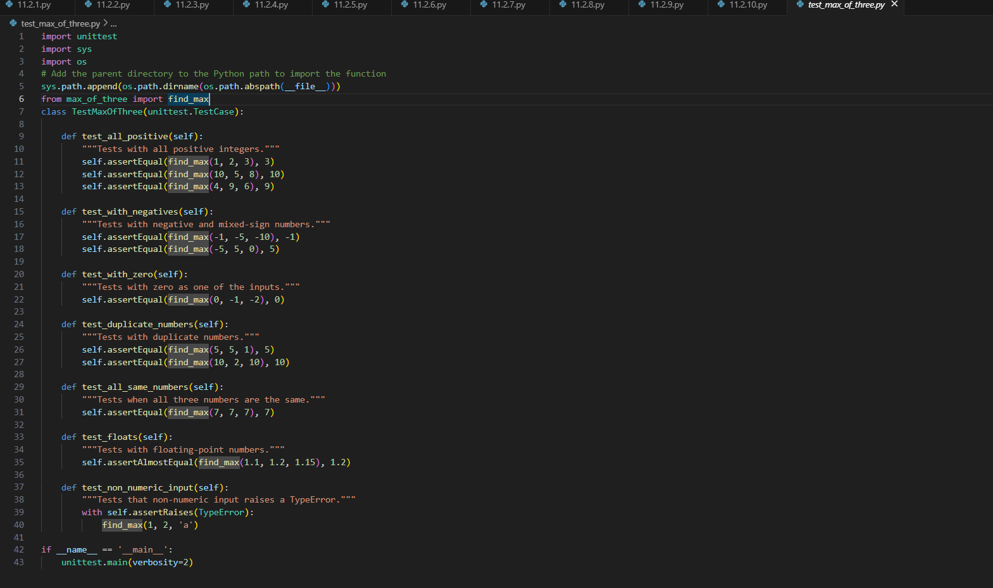

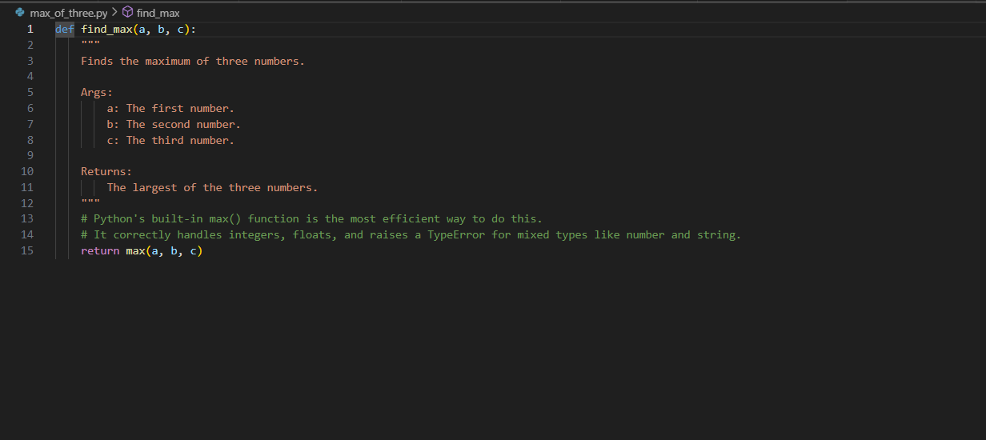

**OUTPUT:**

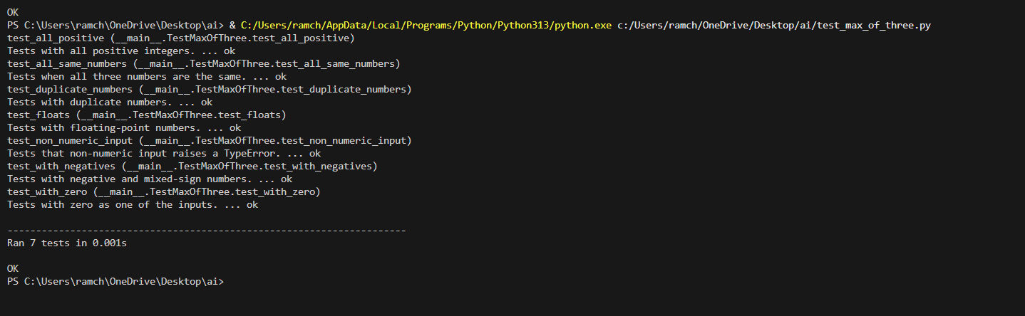

**OBSERVATION:**

The test cases generated by the ai are more efficient of check whether the maximum of the three numbers. It has given many more conditions to test the function.

**TASK-04:**

Use TDD to write a shopping cart class with methods to add, remove, and get total price. First write tests for each method, then generate code using AI

**PROMPT:**

Generate the python code for the shopping cart which add, remove, total price of the items which are present in the cart. Also give the test cases to check whether the given functions are in an efficient way or not.

**CODE:**

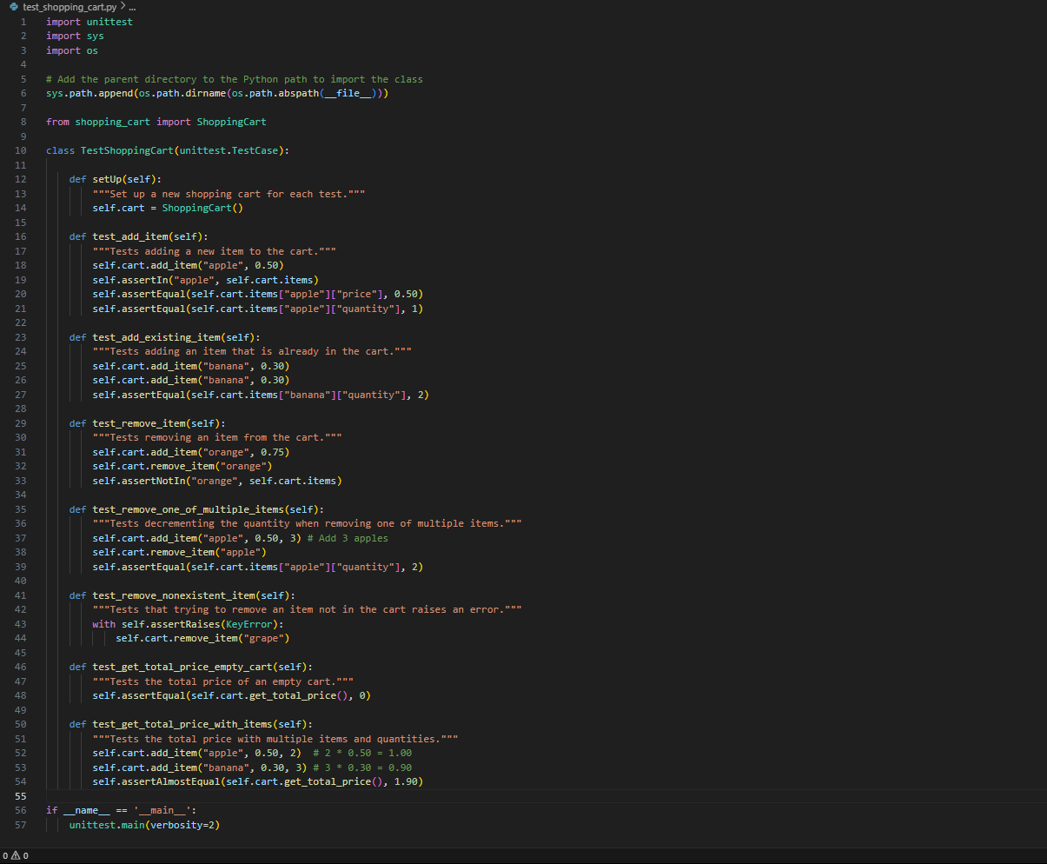

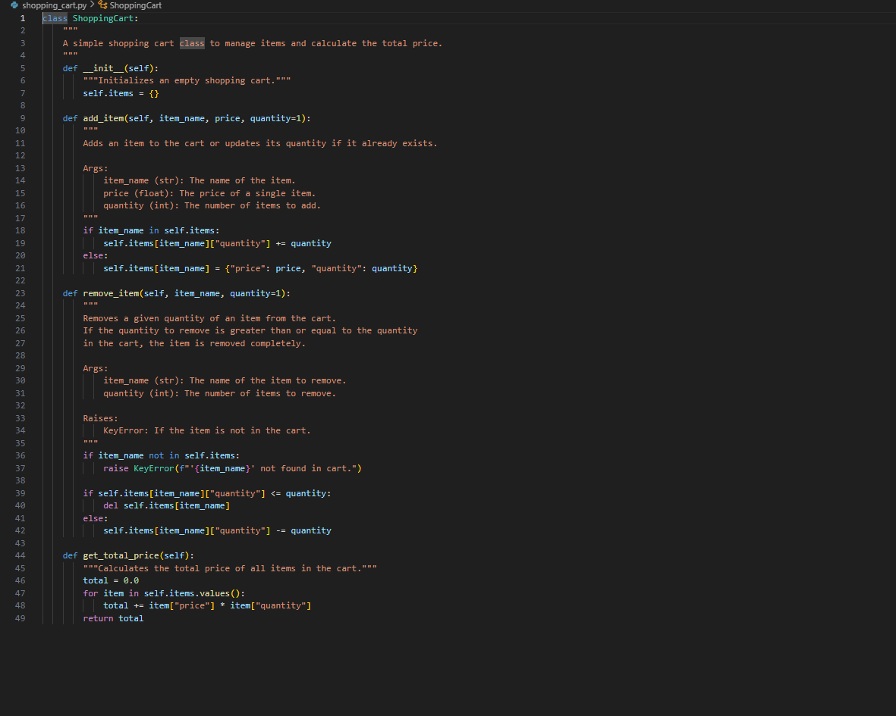

**OUTPUT:**

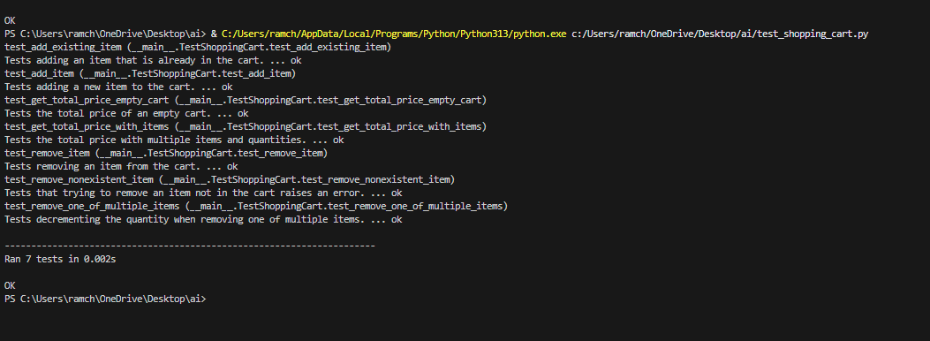

**OBSERVATION:**

The code given by the ai is in an efficient way to find the total bills, adding items , remove items. And the test cases generated by it are more efficient to find the efficiency of the code.

**TASK-05:**

Write tests for a palindrome checker (e.g., is_palindrome("level") → True). Let Copilot suggest the function based on test case expectations.

**PROMPT:**

Write a python code to find whether the entered number or word is a palindrome or not also generate the test cases to find the efficiency of the code.

**CODE:**

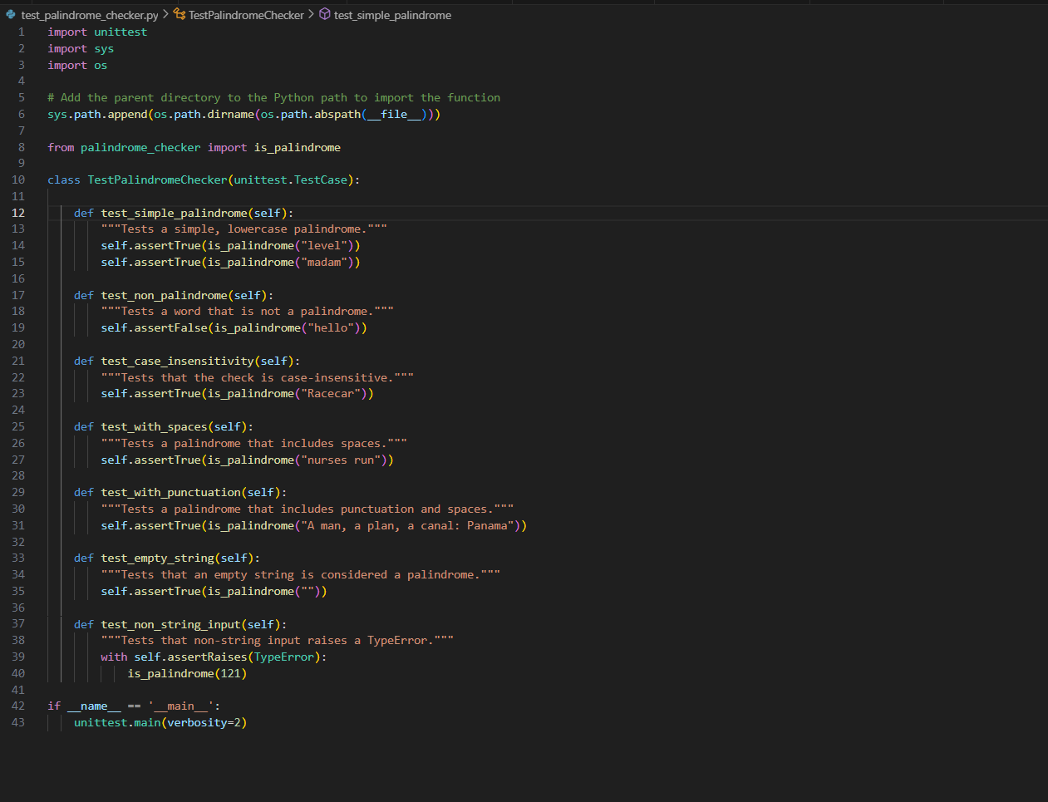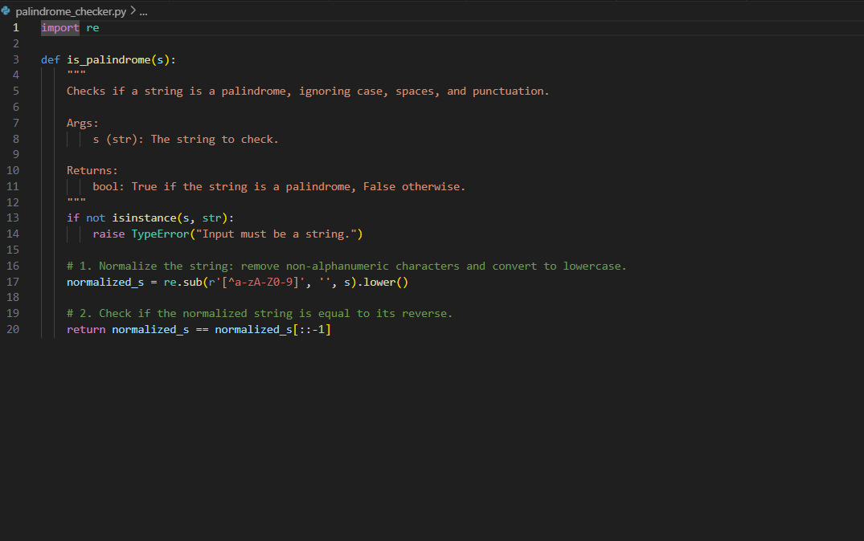

**OUTPUT:**

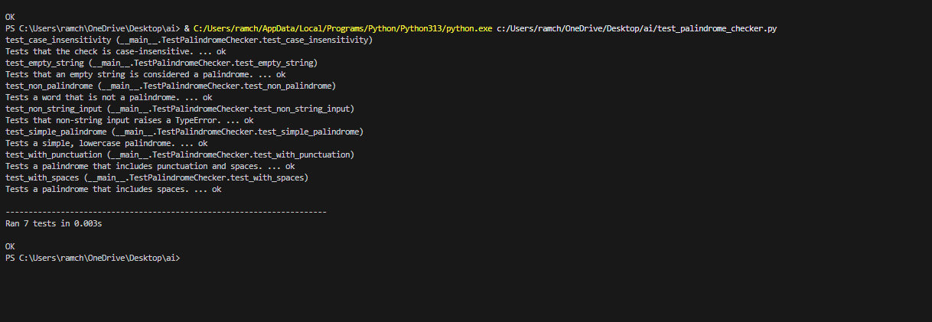

**OBSERVATION:**

The ai generated code which checks whether the entered number or palindrome is palindrome or not. It generated a function which takes an input and checks for the palindrome and gives the appropriate result. It also generated the test cases to check the accuracy of the code.